**TO START:**

* Create a new database named "CompanyDB."

CREATE DATABASE CompanyDB;

* Create a schema named "Sales" within the "CompanyDB" database.

CREATE SCHEMA Sales;

* Create a table named "employees" with columns: employee_id (INT), first_name (VARCHAR), last_name (VARCHAR), and salary (DECIMAL) within the "Sales" schema.

Note: on employee_id use sequence **NOT** Identity.

CREATE SEQUENCE Sales.cnt

start with 1

INCREMENT by 1;

CREATE TABLE Sales.employees

(

employee_id INT PRIMARY KEY

DEFAULT (NEXT VALUE FOR Sales.cnt),

first_name VARCHAR(30),

last_name VARCHAR(30),

salary DECIMAL(10,2),

);

* Alter the "employees" table to add a new column named "hire_date" with the data type DATE.

ALTER TABLE Sales.employees

Add hire_date date;

* **Required:** Add mock data to this table use [https://www.mockaroo.com](https://www.mockaroo.com/)

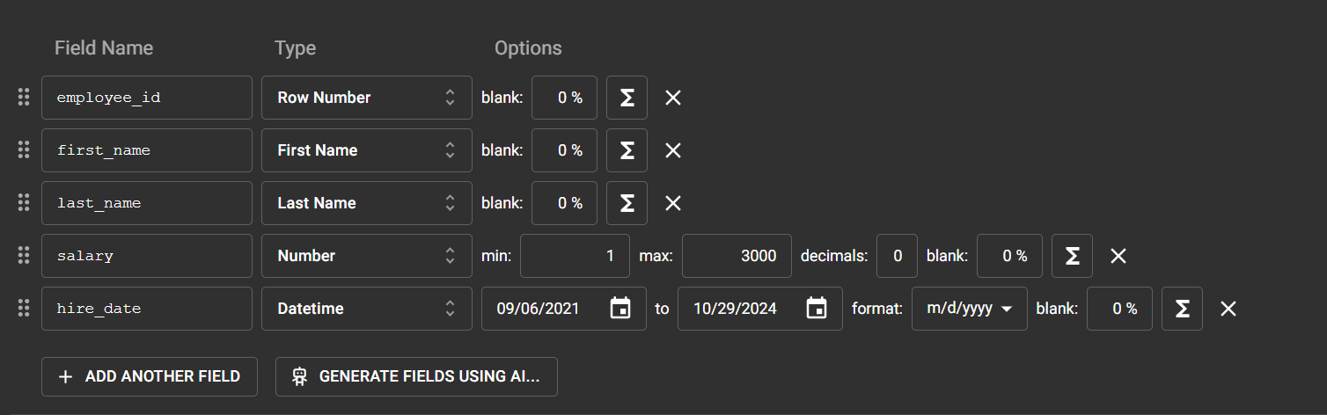

**DATA MANIPULATION Exercises:**

* Select all columns from the "employees" table.

SELECT *

FROM Sales.employees;

* Retrieve only the "first_name" and "last_name" columns from the "employees" table.

SELECT first_name,last_name

FROM Sales.employees;

* Retrieve “full name” as a one column from "first_name" and "last_name" columns from the "employees" table.

SELECT first_name+' '+last_name AS 'Full Name'

FROM Sales.employees;

* Show the average salary of all employees.

SELECT AVG(Sales.employees.salary) AS 'average of salary'

FROM Sales.employees;

* Select employees whose salary is greater than 50000.

SELECT *

FROM Sales.employees

WHERE Sales.employees.salary>5000;

* Retrieve employees hired in the year 2020.

SELECT *

FROM Sales.employees

WHERE year(hire_date) = '2020';

* List employees whose last names start with 'S.'

SELECT *

FROM Sales.employees

WHERE Sales.employees.last_name like 'S%';

* Display the top 10 highest-paid employees.

SELECT top(10) *

FROM Sales.employees

order by salary desc

* Find employees with salaries between 40000 and 60000.

SELECT *

FROM Sales.employees

WHERE salary between 40000 and 60000;

* Show employees with names containing the substring 'man.'

SELECT *

FROM Sales.employees

WHERE first_name like '%man%';

* Display employees with a NULL value in the "hire_date" column.

SELECT *

FROM Sales.employees

WHERE hire_date is null;

* Select employees with a salary in the set (40000, 45000, 50000).

SELECT *

FROM Sales.employees

WHERE salary in (40000 ,45000, 50000);

* Retrieve employees hired between '2020-01-01' and '2021-01-01.'

SELECT *

FROM Sales.employees

WHERE hire_date between '2020-01-01' and '2021-01-01';

* List employees with salaries in descending order.

SELECT *

FROM Sales.employees

order by salary desc

* Show the first 5 employees ordered by "last_name" in ascending order.

SELECT top(5) *

FROM Sales.employees

order by last_name asc;

* Display employees with a salary greater than 55000 and hired in 2020.

SELECT *

FROM Sales.employees

WHERE salary >55000 and year(hire_date) = '2020';

* Select employees whose first name is 'John' or 'Jane.'

SELECT *

FROM Sales.employees

WHERE first_name in ('John','Jane');

* List employees with a salary less than or equal to 55000 and a hire date after '2022-01-01.'

SELECT *

FROM Sales.employees

WHERE salary <= 55000 and hire_date >'2022-01-01';

* Retrieve employees with a salary greater than the average salary.

SELECT *

FROM Sales.employees

WHERE salary > (select avg(salary) from Sales.employees);

* Display the 3rd to 7th highest-paid employees.

SELECT *

FROM(

SELECT * ,ROW_NUMBER() OVER(order by salary Desc) AS HS

FROM Sales.employees

) as newTable

WHERE HS between 3 and 7;

* List employees hired after '2021-01-01' in alphabetical order.

SELECT *

FROM Sales.employees

WHERE hire_date >'2021-01-01'

order by first_name,last_name;

* Retrieve employees with a salary greater than 50000 and last name not starting with 'A.'

select *

from Sales.employees

where salary >50000 and last_name not like 'A%'

* Display employees with a salary that is not NULL.

select *

from Sales.employees

where salary is not null;

* Show employees with names containing 'e' or 'i' and a salary greater than 45000.

select *

from Sales.employees

where salary >45000 and (first_name +' '+ last_name) like '%e%' or

(first_name +' '+ last_name) like '%i%';